[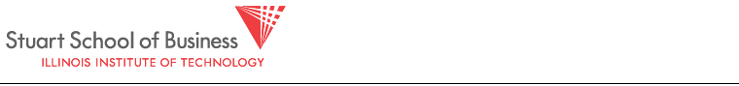](http://www.stuart.iit.edu/)

VPM (MSF 504)

Homework 4: Due May 1

**One submission per group through Blackboard. You can work in groups of up to 4 people. Each group turns in only one solution set with all members’ names listed on the front.**

**We are going to have fun with Black-Litterman!**

We have the set of 60 months of returns for the S&P 500 index and 19 other stocks that we used in Homework 2. I also have a worksheet called Market Caps. It gives the market capitalizations of the 19 stocks that are used as the benchmark (or, reference portfolio).

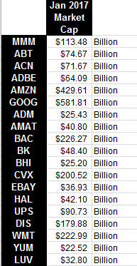

1. Find the covariance matrix of excess returns using the sample data. Also find the one factor structural covariance matrix, using betas from a regression of stock excess returns against SPY (S&P 500) excess returns. Multiply the covariance matrix by 12 (to annualize the variances and covariances) and report the annualized covariance matrix

2. Find the one factor structural covariance matrix, using betas from a regression of stock excess returns against SPY (S&P 500) excess returns. Estimate and report a 19-by-19 covariance matrix of monthly excess returns for the 19 stocks using , where is a 19-by-19 matrix of residual returns with all off-diagonals are zeros. Multiply the covariance matrix by 12 and report this annualized structural covariance matrix.

3. Shrink the sample covariance matrix by using . Yeah, you know the drill: report this covariance matrix

4. We have annual risk-free rate of 3%, and we expect a **reference portfolio** risk premium of 6% over the next year. Using this information—along with the stocks’ market caps—find the expected returns of the reference portfolio. Report these expected returns.

5. **Views:** Our crack research staff of analysts has the following views that we wish to incorporate into our analysis, Black-Litterman style:

1. ADM, AMAT, and DIS will each under-perform their reference returns by 3% over the next year, ±4% with 90% confidence. (This is an ex ante alpha for these stocks of −3%, so the view is that the returns on these stocks will be 3% less than the ones you calculated in part (4).
2. AMZN is expected to have a total return of 16% over the next year, ±5%, with 90% confidence.
3. LUV returns will outperform UPS returns by 4% over the next year, ±5%, with 90% confidence.

Report the Portfolio of Positions, **P**, the view vector of expected returns, **v** (little “v”),and Covariance Matrix of the Views, **V** (big “V”).

6. Use  and  from part (3)—and equation —to estimate the Black-Litterman weighted vector of expected returns for all 19 stocks.

7. The fund manager wants to take the expected returns from part (6), and the covariance matrix from part (3), and find the portfolio weights of the 19 stocks that will maximize it’s Sharpe ratio. She will the following problem to do this:

, for 

She will then find the risk-aversion parameter what set’s the sum of the weights = 1. That’s the portfolio in which she will invest.

Report:

1. The portfolio weights of the 19 stocks
2. The expected return of the portfolio
3. The volatility of the portfolio
4. The Sharpe Ratio of the portfolio with Black Litterman Expected returns, compared to Sharpe Ratio of the market-value-weighted portfolio using R eference Expected returns.

8. Repeat steps (6) and (7) using .